Data Binding

🔗 What is Data Binding
# Source: AI Source: Provided by: [Data Path: Persons Table -> ID Column: 1, Name_En Column: Motasem Essam] -> From: [ChatGPT] on [1/23/2026]
Data Binding is the technique of connecting UI elements (View or Template) to the underlying data (ViewModel or Model) so that changes in the data automatically update the UI, and sometimes vice versa.
👉 Think of Data Binding as a bridge between UI and state — it keeps the interface reactive without manual DOM updates.

🔑 Key Points
# Source: AI Source: Provided by: [Data Path: Persons Table -> ID Column: 1, Name_En Column: Motasem Essam] -> From: [ChatGPT] on [1/23/2026]
- Keeps UI and data in sync automatically
- Reduces the need for manual DOM manipulation
- Can be one-way (data → UI) or two-way (data ↔ UI)
- Works closely with ViewModel or Controller depending on the pattern
- Improves maintainability, readability, and testability

1️⃣ One-Way Data Binding
# Source: AI Source: Provided by: [Data Path: Persons Table -> ID Column: 1, Name_En Column: Motasem Essam] -> From: [ChatGPT] on [1/23/2026]
Definition: Data flows in a single direction — from the data source (Model/ViewModel) to the UI (View/Template).
The UI automatically updates when the data changes, but user input does not directly update the data source.
Example: One-Way Binding
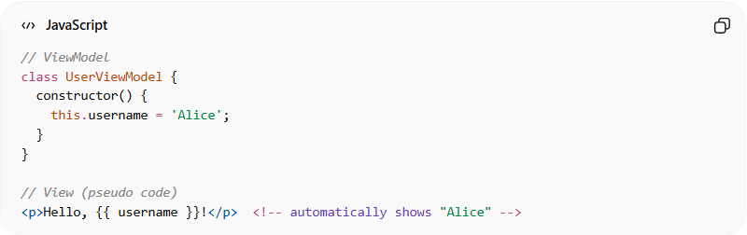
// ViewModel
class UserViewModel {
constructor() {
this.username = 'Alice';
}
}

// View (pseudo code)
<p>Hello, {{ username }}!</p> <!-- automatically shows "Alice" -->
- Changing username in the ViewModel updates the UI.
- Typing in the UI does not change username automatically.
✅ Use case: Display-only data, read-only labels, dashboards.

One-Way Binding = simpler, safer, easier to debug

2️⃣ Two-Way Data Binding
# Source: AI Source: Provided by: [Data Path: Persons Table -> ID Column: 1, Name_En Column: Motasem Essam] -> From: [ChatGPT] on [1/23/2026]
Definition: Data flows both ways — from data source to UI and from UI back to data source.
The UI reflects the data automatically, and user input automatically updates the underlying data.
Example: Two-Way Binding (Vue.js)
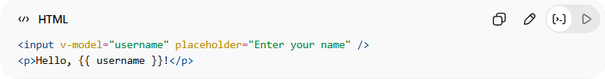
<input v-model="username" placeholder="Enter your name" />
<p>Hello, {{ username }}!</p>
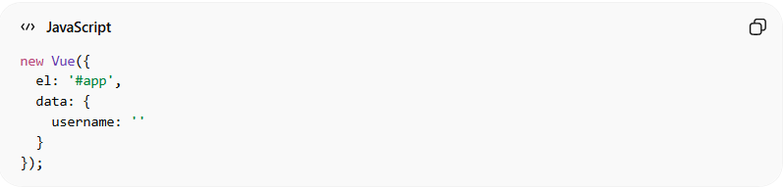
new Vue({
el: '#app',
data: {
username: ''
}
});
- Typing in the input automatically updates username.
- Changing username programmatically updates the input field.
✅ Use case: Forms, interactive UI elements, editable tables.
Two-Way Binding = more interactive, great for user input, but can lead to complexity if overused

🔄 Key Differences
# Source: AI Source: Provided by: [Data Path: Persons Table -> ID Column: 1, Name_En Column: Motasem Essam] -> From: [ChatGPT] on [1/23/2026]
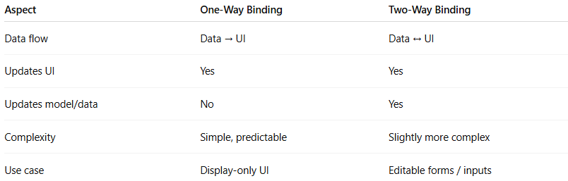
Aspect | One-Way Binding | Two-Way Binding
Data flow | Data → UI | Data ↔ UI
Updates UI | Yes | Yes
Updates model/data | No | Yes
Complexity | Simple, predictable | Slightly more complex
Use case | Display-only UI | Editable forms / inputs

Example: One-Way Data Binding (ViewModel → View)
# Source: AI Source: Provided by: [Data Path: Persons Table -> ID Column: 1, Name_En Column: Motasem Essam] -> From: [ChatGPT] on [1/23/2026]
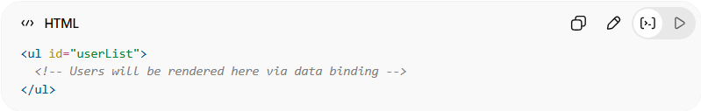
<ul id="userList">
<!-- Users will be rendered here via data binding -->
</ul>
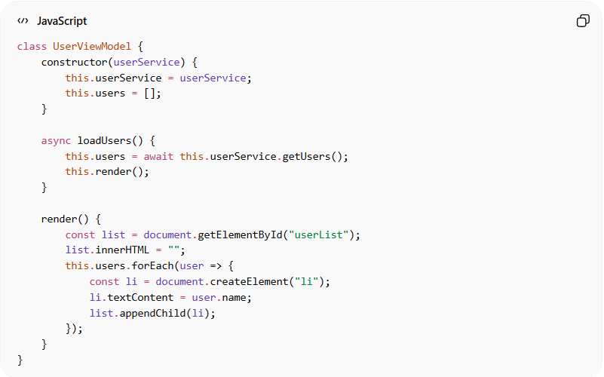
class UserViewModel {
constructor(userService) {
this.userService = userService;
this.users = [];
}

async loadUsers() {
this.users = await this.userService.getUsers();
this.render();
}

render() {
const list = document.getElementById("userList");
list.innerHTML = "";
this.users.forEach(user => {
const li = document.createElement("li");
li.textContent = user.name;
list.appendChild(li);
});
}
}
✅ Here:
- users in ViewModel drives the content of the template
- The UI updates automatically when ViewModel state changes

🔄 Example: Two-Way Data Binding (UI ↔ ViewModel)
# Source: AI Source: Provided by: [Data Path: Persons Table -> ID Column: 1, Name_En Column: Motasem Essam] -> From: [ChatGPT] on [1/23/2026]
Using a reactive framework like Vue.js:
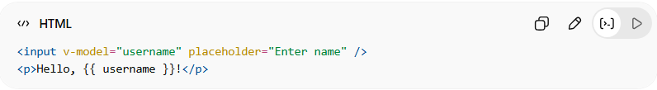
<input v-model="username" placeholder="Enter name" />
<p>Hello, {{ username }}!</p>
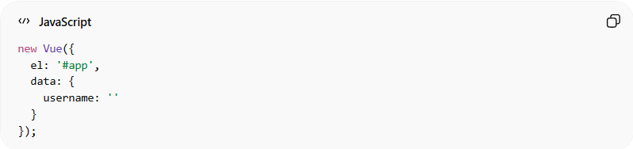
new Vue({
el: '#app',
data: {
username: ''
}
});
✅ Here:
- Typing in the input updates the ViewModel automatically
- Updating the ViewModel programmatically updates the UI

❌ Bad Example (No Data Binding)
# Source: AI Source: Provided by: [Data Path: Persons Table -> ID Column: 1, Name_En Column: Motasem Essam] -> From: [ChatGPT] on [1/23/2026]
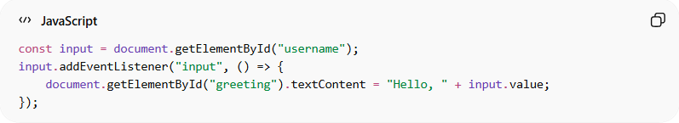
const input = document.getElementById("username");
input.addEventListener("input", () => {
document.getElementById("greeting").textContent = "Hello, " + input.value;
});
Problems:
- Manually updates DOM → verbose and error-prone
- Harder to maintain for large apps
- Breaks separation of concerns

✅ Good Practices
# Source: AI Source: Provided by: [Data Path: Persons Table -> ID Column: 1, Name_En Column: Motasem Essam] -> From: [ChatGPT] on [1/23/2026]
- Use frameworks/libraries for reactive data binding (Vue, React, Angular)
- Keep ViewModel/UI state separate from DOM manipulation
- Prefer one-way binding where possible for predictability
- Use two-way binding for forms or interactive inputs

🔑 Summary
# Source: AI Source: Provided by: [Data Path: Persons Table -> ID Column: 1, Name_En Column: Motasem Essam] -> From: [ChatGPT] on [1/23/2026]
Data Binding ensures the UI always reflects the underlying state, reducing boilerplate code and keeping the interface reactive, maintainable, and clean.

